INTERNSHIP REPORT
ON
FINANCIAL ACCOUNTING IN TALLY ERP.9
BY
SONAM DEVI
UNIVERSITY ROLL NO. 2025193916


DEPARTMENT OF COMMERCE

GOVERNMENT COLLEGE AHARWALA (BILASPUR)
(KURUKSHTRA UNIVERSITY, KURUKSHTRA)

YEAR OF SUBMISSION - 2026

ACKNOWLEDGMENT
I would like to express my deepest gratitude to all those who have guided, supported and encouraged me throughout the course of my internship.
First and foremost, I would like to extend my sincere thanks to Dr. Sarvjeet Kaur, Principal Government College, Aharwala (Bilaspur), for her inspiring leadership, encouragement and providing me this opportunity, resources and a platform to enhance my knowledge and skill,
I would like to extend my sincere thanks to Mr. Rahul Saini, Teacher of Authorized Training Partner of: M/s Global Infosys, and C Language Internship Mentor, for his constant guidance, motivation and valuable insights. I am also grateful to Ms. Anukriti Mam, Internship Supervisor, and Ms. Chanchal Rani, Internship Incharge, for their continuous support and encouragement My heartful thanks Ms. Aarti Arora, Internship Coordinator, for her assistance and cooperation during the internship period.
Finally, extend a special thanks to my father, Mr. Jasbir Singh for always being my strongest support system and providing me with the necessary resources, care, and encouragement to achieve my goals.

TABLE OF CONTENTS

- Certificate
- Acknowledgments
- About the organization
- Objectives of Internship
- Details of Work done
- Learning Experiences
- Learning Outcomes
- Conclusion / Summery
- Attachments

INTRODUCTION
Financial accounting is the formal process of recording, summarizing, and reporting business money transactions. It creates standard reports like balance sheets and income statements. These reports show a company's financial health to people outside the business, such as investors, banks, and tax offices
Tally ERP.9 is an accounting software record the day by day transaction in business.

ABOUT THE ORGANIZATION
Global Infosys, Jagdhri is a computer education and IT training institute dedicated to providing technical education and practical knowledge to students. The organization focuses on developing programming, software development, and computer application skills through classroom instruction and hands-on laboratory practice. It aims to bridge the gap between academic learning and industry requirements by offering practical training and internship opportunities.
The institute provides training in various programming languages and software technologies, enabling students to build strong technical foundations. During the internship, students gain practical experience by writing programs, solving programming problems, and developing small software applications under the guidance of experienced instructors.
Global Infosys provides training in various computer-related subjects, such as:
- Financial accounting in Tally ERP.9
- Tally prime
- MS Office, MS excel, MS Powerpoint
- Internet Applications
- Database Management
- Software Development Basics
Global Infosys, Jagdhri provided practical training about Tally ERP.9 The training covered fundamental concepts such as basics of Accounting and tally Setup, Voucher Entry and Inventory Management, Advanced Accounting and Banking.

OBJECTIVES OF INTERNSHIP

- To gain practical knowledge of Accounting and Tally.
- To understand calculate the net result of business operations over a specific period.
- To replace human memory by systematically recording every financial transaction.
- To state the exact value of assets and liabilities using a Balance Sheet.
- To track stock movements, multiple godowns, and manufacturing processes seamlessly.

DETAIL OF WORK
Week 1: Basics and Company Setup
COMPANY :
In Tally.ERP 9, a Company is the basic operational unit and the central database where you store all financial data, transactions, and inventory records for a specific business entity. It acts as an independent electronic file or folder for a single organization.
Day 1-2: Learn how to install Tally.ERP 9 and create a new company, alter company, shut company and select company
Day 3-4: Understand accounting terms like debit, credit, assets, and liabilities.
LEDGER :
In Tally.ERP 9, a Ledger is an individual account head used to store and identify transactions of a similar nature. It is the actual account where money values are recorded, and you cannot enter a transaction in Tally without using at least two ledgers (Debit and Credit).
Day 5-7: Create single and multiple ledger accounts and groups, display and alter groups

Week 2: Recording Financial Transactions
feeding stock in a godown:
means entering or recording the physical movement, storage, and location of inventory items into a specific warehouse or storage room
Day 1-2: Practice FEEDING STOCK IN GODWON AND STOCK TRANSFER

Day 3-4: record sales and purchase transactions with proper invoice modes.
Day 5-7: Handle debit notes, credit notes, and journal adjustments.

Week 3: Control Instructions
- Decision Control Instruction
- Switch Case Control Statements
- Iterative Control Instruction
1. Decision control Instructions:
A. If Else
B. Else If
A. If Else:
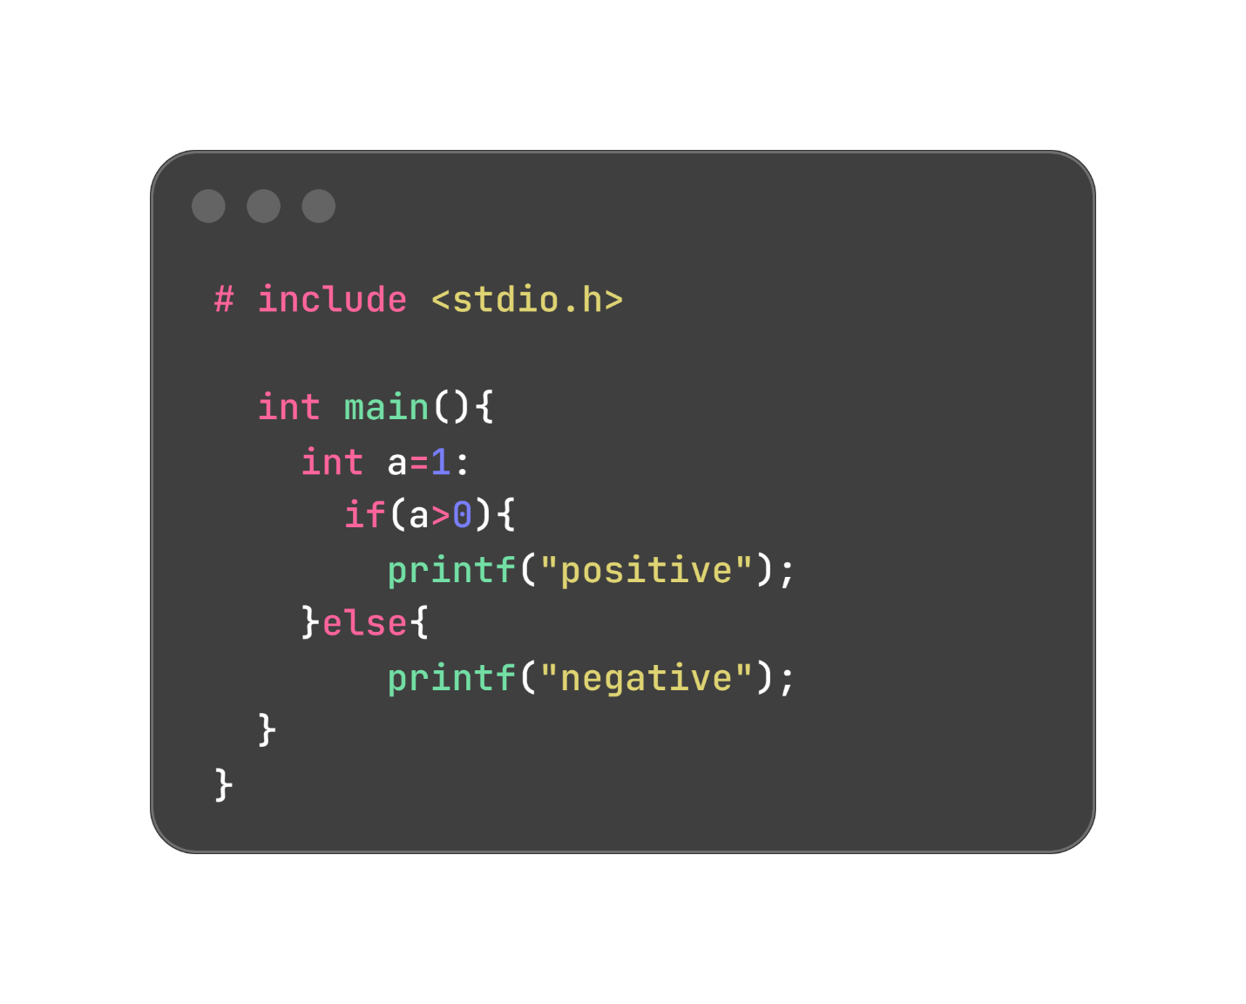
Output: positive
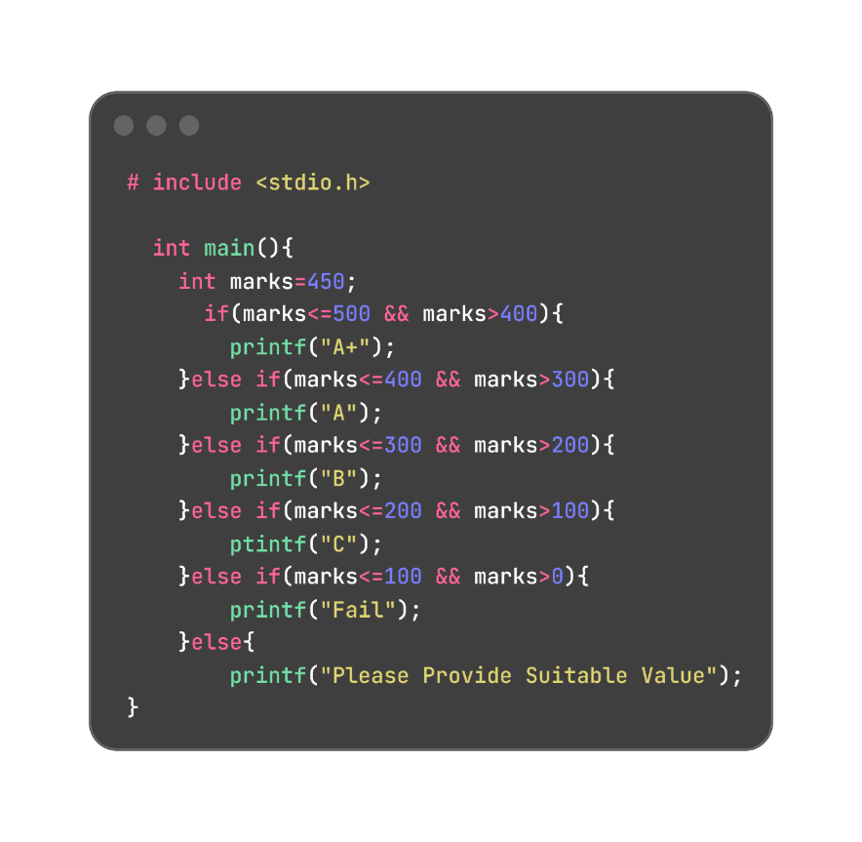
B. Else If:

Syntax
if (condition){
code;
code;
}else{ code;
}
Output: A+

2.Switch Case Control Statements:
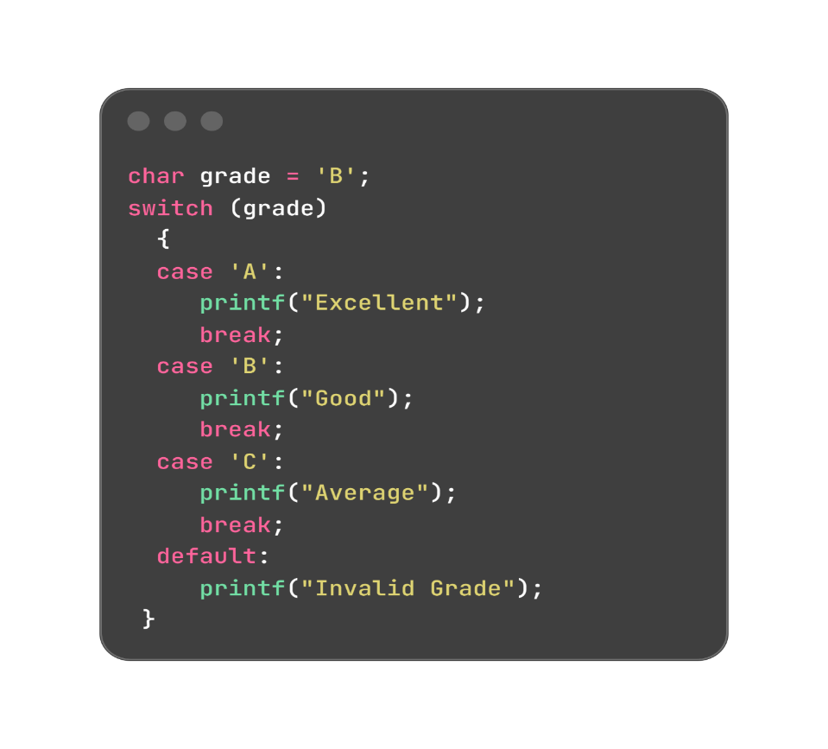
Syntax
if (condition){
code;
}else if(condition){
code;
}else{
code;
}
Output: Good
Week:4
3.Iterative Control Instruction:
- while
- do while
- for
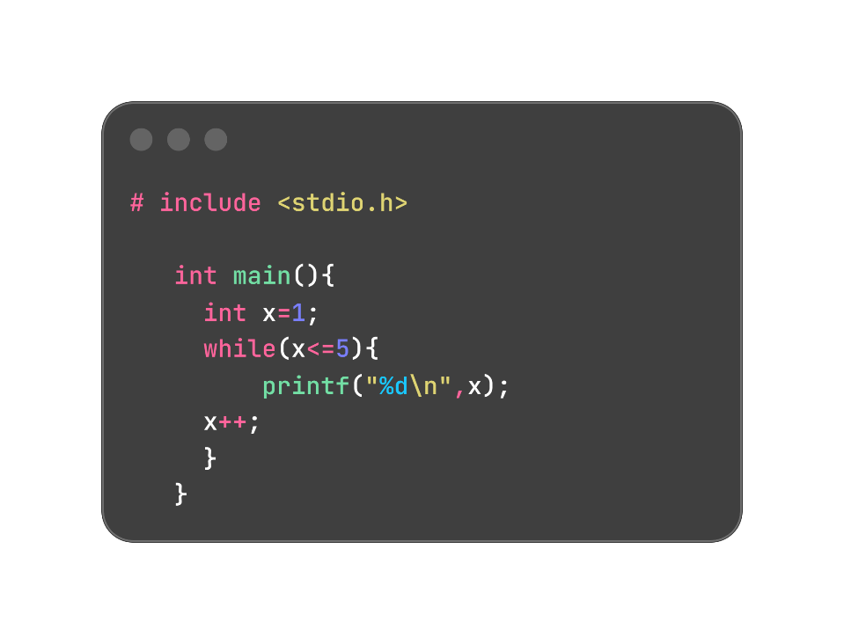
- While:

Syntax
variable;
while(condition){
code;
increment;
}

Output: 1
2
3
4
5

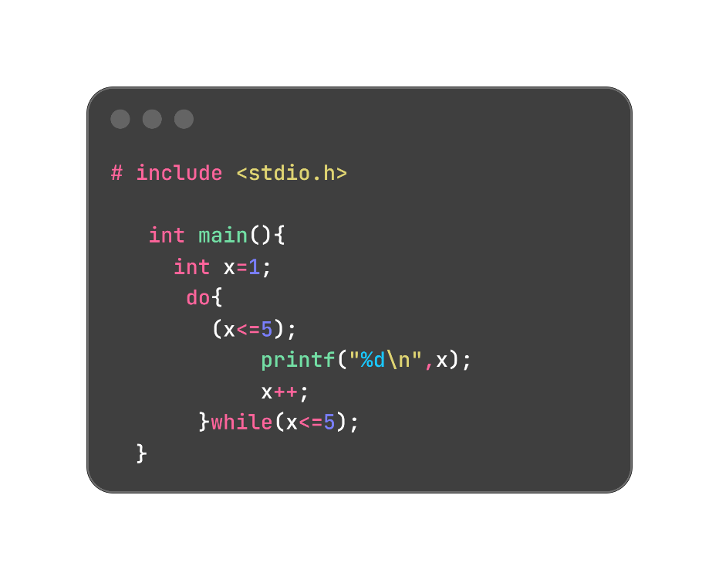
- Do while:
Syntax
variable;
do{
code;
increment;
}while(condition);
Output: 1
2
3
4
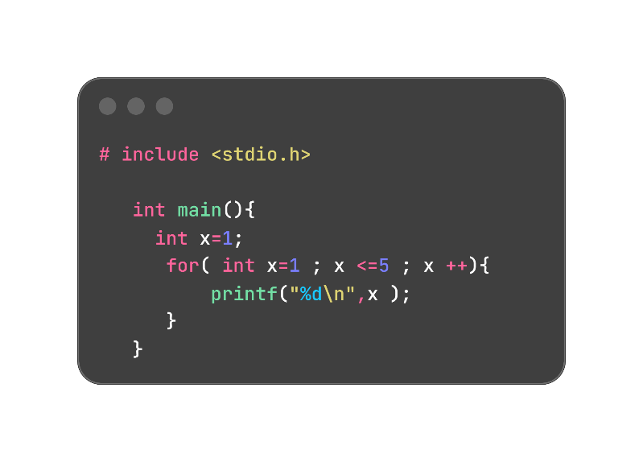
5
- For:
Output: 1
2
3
4
5

Syntax
for(variable; condition; increment){
code;
}
Functions: A function is a block of code that does a specific job. It runs only when it is called. It can take input and give output. It helps make the program simple and easy to understand. Using functions we can enable code reusability.
The return statement is used to exit a function and go back to the place from where it was called. return statement can contain an expression that gets evaluated and the value is returned.
Syntax
return_type function_name(parameters){
code;
[return[value]];
}
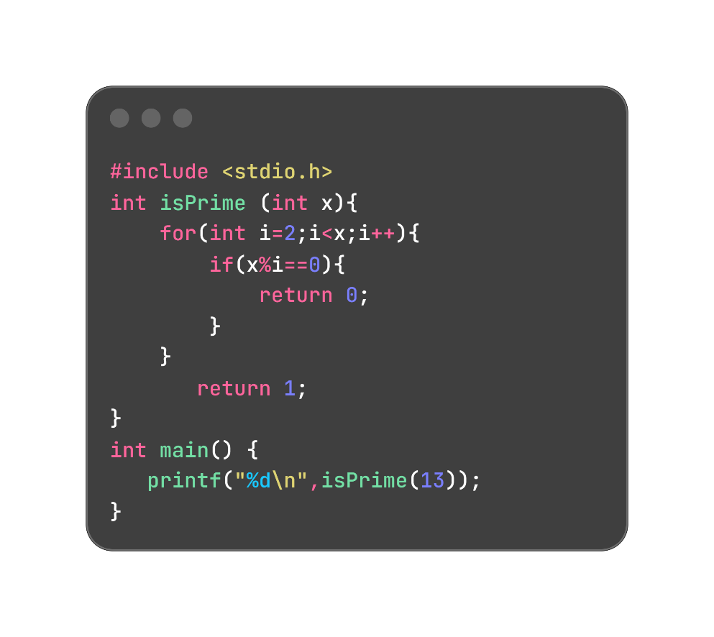
Example:

Output: 1
Week 5: Array, Structure, Union, and Pointer
Array
An array is a collection of similar data types stored in contiguous memory locations. It allows you to store and access multiple values using a single variable name with an index. Basically it can store multiple variables in a single array.
yntax Example data_type array_Name [ size

